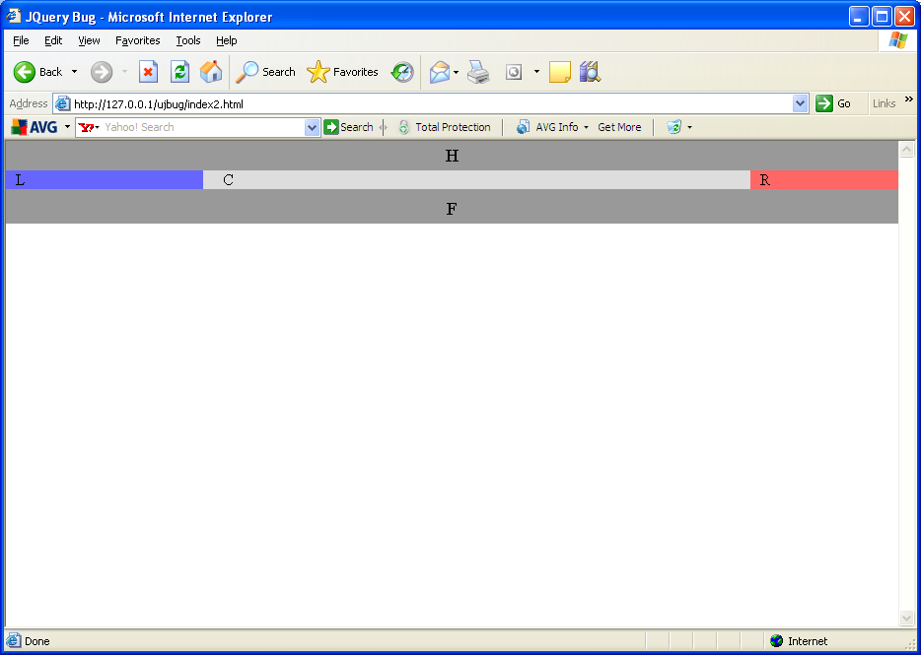

Add line:
<script type='text/javascript' src='jquery.js?ver=1.3.2'></script>

Creates a bug in IE6. Firefox works fine. Try resizing the browser and what is supposed to be the left hand column jumps to the centre.
